Visualizing Citi Bike Demand and Flow Patterns Across New York City
Reeahna Abraham · E538 Information Visualization
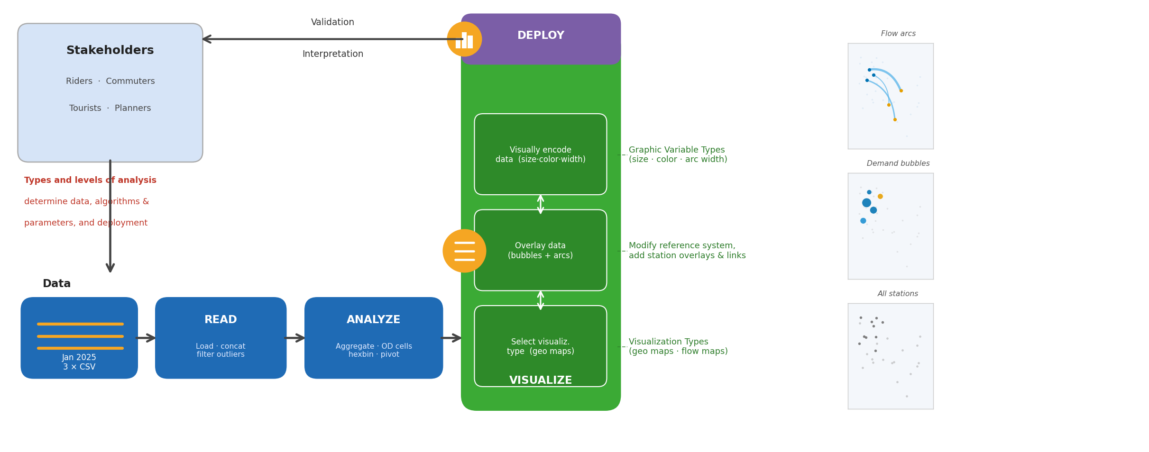
Fig. 1. Visual analytics pipeline: stakeholder needs drive data selection, analysis, and visual encoding. Trip data is read, filtered, and aggregated into coordinated geospatial maps (Figs. 2–3) and deployed as static exports. Code and data: github.iu.edu/ahnabrah/citi_bike

1. INTRODUCTION AND PRIOR WORK
Bike-share demand imbalances are a persistent urban mobility challenge: riders can experience empty docks and full stations while operators struggle to allocate rebalancing resources. Visualizing spatial and temporal demand patterns can make these legible to both system users and planners. Prior flow map research by Holten and van Wijk [1] established that curved arc encodings reduce visual clutter in origin-destination datasets—a finding directly applied to the corridor arcs in Fig. 3. Munzner’s visualization design framework [2] informed the pairing of a bubble map for magnitude comparison with a flow map for relational corridor data. Existing Citi Bike analyses focus largely on demand forecasting via machine learning, producing outputs not interpretable by non-technical stakeholders. This project addresses that gap by prioritizing visual clarity and colorblind accessibility.
1.1 Stakeholder Groups
Riders (commuters, students, tourists) need to reduce uncertainty about bike availability and make informed station-planning decisions. Citi Bike operators and city transportation planners make capital and scheduling decisions—where to add docks, when to dispatch rebalancing trucks, and how to assess service equity. They need stable, reproducible spatial patterns at station and corridor scale.
1.2 Stakeholder Needs
Riders: identify high-demand neighborhoods; see where member and casual riding concentrates across the city. Operators and planners: pinpoint top-volume stations and corridors for rebalancing; evaluate electric vs. classic bike distribution for fleet allocation; compare rider-type geographies for equity analysis. Every design decision in the prototype traces directly to one of these needs.
2. DATA ACQUISITION
Three January 2025 trip files were downloaded from the Citi Bike System Data portal and concatenated. This publicly available secondary source directly captures the spatial and temporal demand patterns needed by both stakeholder groups. No primary data collection was required. All data and code are available at github.iu.edu/ahnabrah/citi_bike.
2.1 Data Sources
File | Description | Size
tripdata_1.csv | Jan 2025 trips, part 1 | ~700K rows
tripdata_2.csv | Jan 2025 trips, part 2 | ~700K rows
tripdata_3.csv | Jan 2025 trips, part 3 | ~700K rows
Table 1. Source files (Citi Bike System Data portal, tripdata.s3.amazonaws.com).
2.2 Data Description, Quality and Coverage
Each row is one completed trip across 13 fields: ride_id, rideable_type, started_at/ended_at, start/end station names and IDs, start/end lat/lng, and member_casual. Spatial coverage: Manhattan, Brooklyn, Queens, Bronx, and Jersey City. Temporal coverage: January 2025 only (winter; not representative of annual behavior). Quality: GPS outliers outside the NYC bounding box removed (~0.3%); trips under 1 min or over 3 hrs excluded (~2.1%); null station/coordinate rows dropped (~0.4%). After cleaning: 2,119,093 rides · 2,153 stations.
3. DATA ANALYSIS
Tools: Python 3.12, pandas (aggregation), NumPy (coordinate snapping), matplotlib 3.10 (rendering). Chosen for reproducibility and static export quality.
Station aggregation (pandas groupby): volume, member/casual split, and bike type per station plus mean coordinates—the appropriate spatial unit for bubble map encoding. Hexbin density (matplotlib): 50-cell grid over 2.1M starts; extent parameter constrained to axis limits to prevent background stretching. Neighborhood OD flows (NumPy): trips snapped to 0.025° grid cells (~1.5 km²); only flows ≥0.05° apart retained. Raw station-pair aggregation was tried first but the top-20 pairs were all adjacent stations (<200 m), producing invisible arcs; grid-cell pooling resolved this. Temporal pivot: 7×24 ride-count matrix from day-of-week × hour cross-tabulation, computed to characterize demand distribution across the week.
4. VISUALIZATIONS
Both geospatial panels use the Okabe-Ito colorblind-safe palette (distinguishable under deuteranopia, protanopia, and tritanopia). No encoding relies on hue alone—size, opacity, and position carry redundant signals. Static 150 dpi PNGs and the generating script are at github.iu.edu/ahnabrah/citi_bike.
4.1 Station Demand Map (Fig. 2)
A dual-layer design addresses overplotting across 2,153 stations. The hexbin background (YlOrRd colormap) encodes density across all 2.1M trip starts, providing a continuous spatial signal readable at city scale. The bubble overlay shows the top 60 stations scaled by volume and colored by casual rider share: dark blue indicates near-0% casual (member-dominated) while amber/yellow indicates 50%+ casual share, as shown in the colorbar. The highest-volume stations are labeled directly on the map. The hexbin answers the rider question (‘where is it busy?’); the bubble color answers the planner question (‘where are casual riders concentrated?’).
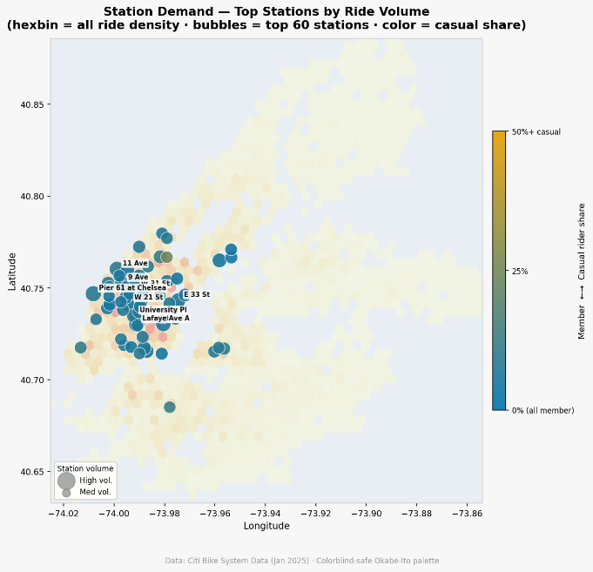
Fig. 2. Station demand map. Hexbin background (YlOrRd) encodes ride density across all 2.1M trip starts. Bubbles show top-60 stations by volume; color encodes casual rider share (dark blue = all-member, amber = 50%+ casual). Top stations labeled.
4.2 Flow Arc Map (Fig. 3)
Fig. 3 shows the top 20 cross-neighborhood corridors as curved Bézier arcs. Arc width and opacity both scale with trip volume, providing redundant encodings of flow magnitude. Curvature (30% of chord length) visually separates overlapping bidirectional flows between the same cell pair; movement direction is indicated by the origin and destination dot markers. All 2,153 stations appear as faint background dots for geographic context. Dark blue dots mark origin cells and amber dots mark destination cells, consistent with the color scheme in Fig. 2. Corridors radiate from a central cluster near Chelsea/Midtown West (lng −73.98, lat 40.75), connecting to neighborhoods across the wider Manhattan grid.
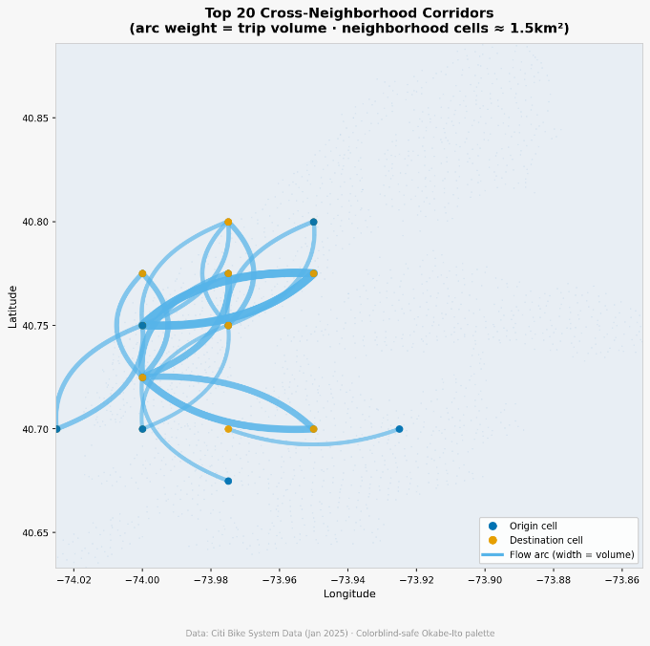
Fig. 3. Cross-neighborhood flow arc map. Top 20 corridors aggregated to ~1.5 km² cells; only flows spanning ≥4 km shown. Arc width and opacity = trip volume. Dark blue = origin cell; amber = destination cell.
5. USAGE AND CRITIQUE OF AI TOOLS
Model: Claude Sonnet 4.6 (Anthropic) via Claude.ai for prototype coding; ChatGPT (OpenAI) used in earlier project weeks for visualization ideation. Criteria: code accuracy, quality of design choices applied without explicit prompting, iteration speed, and transparency (ability to read and explain every line).
Key prompts: “Create a Python geospatial prototype with a colorblind-safe palette” · “The map stretches to California—add a NYC bounding box” · “The OD map shows scattered dots—use neighborhood grid cells.” Describing the observed visual problem rather than the assumed cause produced the most effective responses.
Impact: Reduced implementation time from ~3 days to one session. AI applied sound design practices (Okabe-Ito palette, arc curvature, dual-layer density encoding) without explicit prompting. However, the OD flow map required five iterations because the root cause—adjacent-station pairs dominating the top-20 ranking—required human diagnosis before an effective prompt could be written.
Limitations: Sandbox lacked network access, blocking interactive libraries (Folium, Plotly) that would better serve riders. Context degradation in long sessions reintroduced previously fixed bugs. Generated code reflected training biases toward common patterns, requiring manual correction for edge cases such as hexbin extent constraints. Recommendations: Use short, scoped sessions; describe observed visual problems rather than assumed causes; always validate on real data before finalizing.
6. INTERPRETATION OF RESULTS
For riders: Fig. 2 shows demand concentrating in the Chelsea/Midtown West corridor around lng −73.98, lat 40.74–40.76, visible as the densest hexbin region. All seven labeled high-volume stations—W 21 St, 9 Ave, 11 Ave, Pier 61, E 33 St, University Pl, and Lafayette Ave A—fall within this tight cluster. Hexbin density drops sharply east of lng −73.94, indicating that riders outside the Chelsea/Midtown West core face a much thinner supply of high-activity stations.
For operators: Fig. 3 shows the dominant corridors radiating from origin cells clustered around lng −73.98, lat 40.75, with the thickest arcs (highest volume) looping within this central cluster. Secondary corridors extend southwest to lat 40.70, north to lat 40.80, and east to lng −73.92—these represent candidate corridors for rebalancing prioritization. Fig. 2 shows nearly all top-60 stations are dark blue (member-dominated); only a handful of bubbles show any casual share, and one isolated station at lat 40.67 with notably higher casual share (appearing green on the blue–amber colorbar) stands out as a candidate location to examine for equity questions.
Unexpected finding: The station demand map (Fig. 2) shows that the highest-volume stations are almost entirely dark blue (near-0% casual share), even leisure-oriented stations like Pier 61 at Chelsea Piers. This indicates the January system is overwhelmingly member-driven across all station types—the assumption that tourist-facing stations would show higher casual share is not supported in winter data. This pattern warrants re-examination in summer months when tourist activity peaks.
Limitations: January data only; seasonal patterns cannot be assessed. Trip data does not capture dock inventory, so actual availability cannot be directly measured. Future work should extend to 12 months and integrate live station status feeds.
ACKNOWLEDGEMENTS
The author thanks the E538 Information Visualization instructors at Indiana University for feedback throughout the four-week project development cycle. Citi Bike trip data is provided publicly by Lyft, Inc. under the Citi Bike System Data License Agreement.
REFERENCES
[1] D. Holten and J. J. van Wijk. A user study on visualizing directed edges in graphs. Proc. ACM CHI, pp. 2299–2308, 2009.
[2] T. Munzner. Visualization Analysis and Design. A K Peters/CRC Press, 2014.
[3] Citi Bike System Data. Lyft, Inc. https://s3.amazonaws.com/tripdata/index.html

